Crookies (Croissant Cookies)
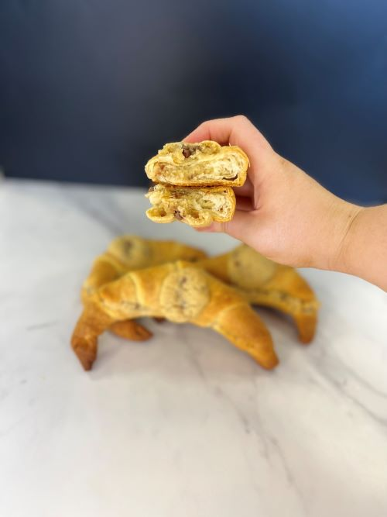

Ingredients:

Carr’s Baker’s Strong Flour 1.900Kg

Salt 0.040Kg

Sugar 0.100Kg

Cold Water (-5°C) 1.100Kg

Yeast 0.120Kg

Milk Powder 0.150Kg

Crispuff Pastry Margarine 0.900Kg

Macphie Soft and Chewy Cookie Mix 1.500Kg

Water 0.180Kg

Chocolate Chips 0.300Kg

Method:
- To make the pastry dissolve the yeast in the cold water, and then add to all the other ingredients (except the Crispuff Pastry Margarine).

Mix for 5 minutes on medium speed

Roll the dough out, then cover half of the dough with Crispuff Pastry and Margarine, fold over the remaining dough so as to cover all the margarine

Give the dough 3 half turns

Pin down to 15mm, cover with plastic, then rest in the freezer for 20 minutes (ideal dough temperature -11°C to - 12°C)

After 20 minutes rest, proceed to finish as required

Cut the dough into equal sized right angle triangles

Roll from the base of the triangle to the tip

Bake at 180°C for 15 minutes until golden

Allow the croissants to cool

Place the Macphie Soft and Chewy Cookie Mix into a stand beater with the water and chocolate chips

Mix until a dough forms

Once the croissants have cooled, cut in half

Fill the croissants with the cookie dough and place a small amount of cookie dough (about 10g) on the top

Bake in the oven at 180°C for 15 minutes until the cookie is baked

