Wicked Witchcraft Cake
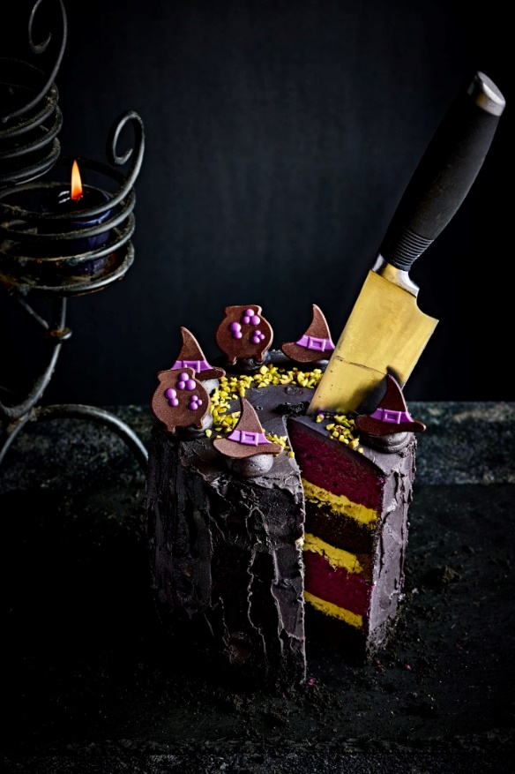

Ingredients:

Braun Purple Velvet Cake 0.500Kg

Braun Black Velvet Cake 0.500Kg

Whole Egg 0.400Kg

Water 0.300Kg

Rapeseed Oil 0.200Kg (Alternatively 120g butter)

Macphie Frosting 0.500Kg

Ingram Black Food Colouring 0.010Kg

IRCA Delicrisp Dubai Pistachio 0.500Kg

IRCA Kiron White Drops 0.170Kg

Dobla Decorations 8 pieces

Chopped Pistachios 0.005Kg

Method:

Add the Braun Purple Velvet with 200g of whole egg, 150g of water and 100g of rapeseed oil into a bowl and mix on a low speed for 1 minute and a medium speed for 5 minutes

In a separate bowl add the Braun Black Velvet with 200g of whole egg, 150g of water and 100g of rapeseed oil into a bowl and mix on a low speed for 1 minute and a medium speed for 5 minutes

Place the batter into greased tins and bake at 190 ֯C for 22 minutes

Remove the cakes from oven and allow to cool

Melt the IRCA Kiron White drops and add to the IRCA Delicrisp Dubai Pistachio, allow to set slightly

Mix the Macphie frosting and the black food colouring, to get a deep black colour heat in the microwave at 15 second intervals mixing between each until the colour deepens and allow to cool

Layer the cake with the IRCA Delicrisp Dubai Pistachio and crumb coat the cakes with the black Macphie frosting and place in the fridge

Once the crumb coat has set put another layer of frosting and pipe on top of the cake

Place the Dobla decorations on the pipings and sprinkle some chopped pistachios

