Kiron Dipped Croissants

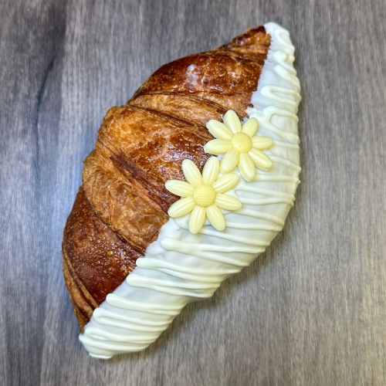
Ingredients:

Carr’s Strong Flour 1.900Kg

Salt 0.040Kg

Sudzucker Caster Sugar 0.100Kg

Water 1.100Kg

AB Mauri Pinnacle Baker’s Yeast 0.120Kg

Skimmed Milk Powder 0.150Kg

Dragsbaek Roll 18 0.900Kg

IRCA Kiron (of your choice 0.300Kg

available in milk, white and dark)

Method:

To make the pastry dissolve the yeast in the cold water, and then add to all the other ingredients (except the Dragsbaek Roll 18).

Mix for 5 minutes on medium speed

Roll the dough out, then cover half of the dough with Dragsbaek Roll 18, fold over the remaining dough so as to cover all the margarine

Give the dough 3 half turns

Pin down to 15mm, cover with plastic, then rest in the freezer for 20 minutes (ideal dough temperature -11°C to - 12°C)

After 20 minutes rest, proceed to finish as required

Cut the dough into large equal sized right angle triangles

Roll from the base of the triangle to the tip

Bake at 180°C for 15 minutes until golden

Allow the croissants to cool

Melt the Kiron in the microwave, dip each croissant in the Kiron and decorate

