Overloaded and Stuffed Cookies

Ingredients:

Raspberry Cheesecake

Macphie American Soft Cookie Mix SG 1.000Kg

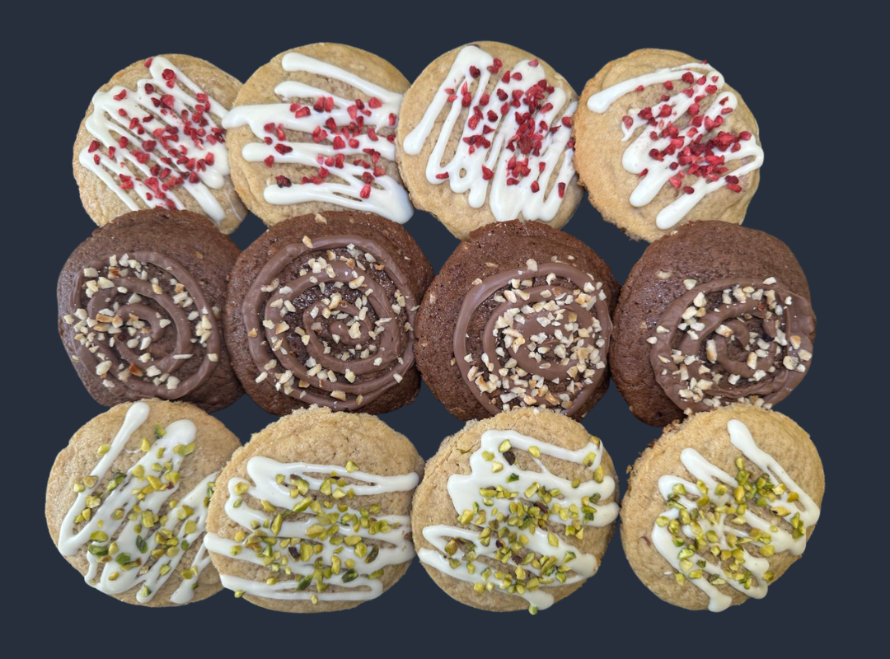
Ballyrashane Butter 0.200Kg

Water 0.140Kg

Belcolade White Chocolate Chunks 0.200Kg

Cream Cheese 0.140Kg

Sugar 0.025Kg

Mather’s Raspberry Seedless Jam 0.050Kg

IRCA Chocosmart Cioccolato Bianco MB 0.100Kg

Freeze Dried Raspberries 0.010Kg

Chocolate Hazelnut

Macphie Soft & Chewy Chocolate Cookie Mix SG 1.000Kg

Water 0.130Kg

Nibbed Hazelnuts 0.150Kg (50g to decorate)

Favorich Milk Chocolate Chips 30% RFA MB 0.100Kg

IRCA Farcinut MB 0.215Kg

IRCA Chocosmart Cioccolato Latte MB 0.100Kg

Pistachio

Macphie American Soft Cookie Mix SG 1.000Kg

Ballyrashane Butter 0.200Kg

Water 0.140Kg

Braun Sizilia Lemon Essence SG 0.005Kg

Belcolade White Chocolate Chunks 0.200Kg

Cream Cheese 0.140Kg

Sugar 0.025Kg

IRCA Chococream Pistachio MB 0.050Kg

IRCA Chocosmart Cioccolate Bianco MB 0.100Kg

Chopped Pistachios 0.0.50Kg

Method:

Raspberry Cheesecake or Pistachio: Mix the cream cheese, sugar and either the Mather’s Raspberry Seedless Jam or IRCA Chococream Pistachio depending on the flavour you are making

Once thoroughly mixed, add to a piping bag and pipe 9g dots onto a lined baking tray and place in the freezer for at least an hour

Chocolate Hazelnut: Add the IRCA Farcinut to a piping bag and pipe 9g dots onto a lined baking tray and place in the freezer for at least an hour

While the fillings are in the freezer, make up the Macphie cookie instructions and add in the inclusions of choice

Weigh the cookie dough into 72g pieces

Once the fillings are frozen, remove from the freezer, and taking the 72g pieces of cookie dough, wrap the dough round the frozen dots and place onto a baking tray

Bake in the oven at 180֯C for 15 minutes

Allow the cookies to cool

Once cooled melt the IRCA Chocosmart and drizzle over the cookies and add toppings

