Mattaroons’ S’mores Brownies

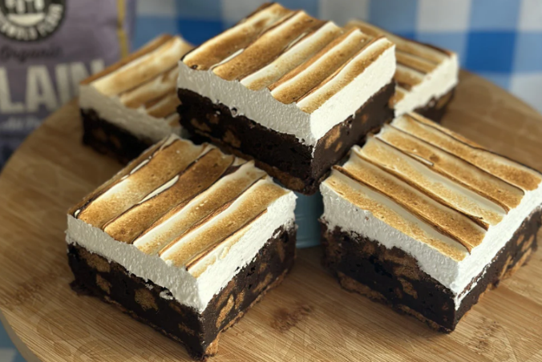
Ingredients:

Biscoff Biscuits 0.325kg

Belcolade Dark Chocolate Drops 0.165kg

Ballyrashane Butter 0.165kg

Caster Sugar 0.165kg

Light Brown Sugar 0.165kg

Medium Eggs 0.180kg

Organic Plain Flour 0.135kg

Cocoa Powder 0.045kg

Dark Chocolate Chips 0.100kg

Biscoff Spread 0.050kg

Renshaw RTU Mallow 0.350kg

Method:

In a lined 9" x 9" square tin place 18 Biscoff biscuits logo side down. Rows of 3 x 6 should fit in the tin. Set this aside to fill shortly.

Melt 165g dark chocolate and 165g unsalted butter in the microwave using 30sec blasts. Once melted set aside to cool and use shortly.

In your mixer or hand whisk, mix together 165g caster sugar, 165g light brown sugar with 3 medium eggs for a couple of mins until it goes pale and doubles in size.

Pour in the cooled melted butter/choc mix and stir through until fully combined.

Sieve in 135g plain Matthew Cotswold flour and 45g coco powder & gently fold through till full incorporated.

Add in 100g broken up Biscoff biscuits and 100g dark choc chips. Gently fold through the brownie batter.

Gently spoon this on top of the tin of biscuits, being careful to not dislodge them. Smooth out to all corners and sides.

Drizzle over 50g melted Biscoff spread and swirl through the top of the brownie.

Bake in a preheated 170°C fan oven for approx. 30mins. Leave to cool to room temp for at least 1hr. At this stage my preference is to refrigerate them overnight to go super fudgy, then decorate with the frosting the next day if you have the time. If you don’t, move on to making the frosting after they have cooled to room temp.

Add the Renshaw RTU Mallow into a piping bag and pipe on top of the cooled brownie and smooth with a pallet knife, creating textures and waves

Use a blowtorch to toast the mallow

Cut and serve

