Orange Blossom, Raspberry and Lemon Cookies

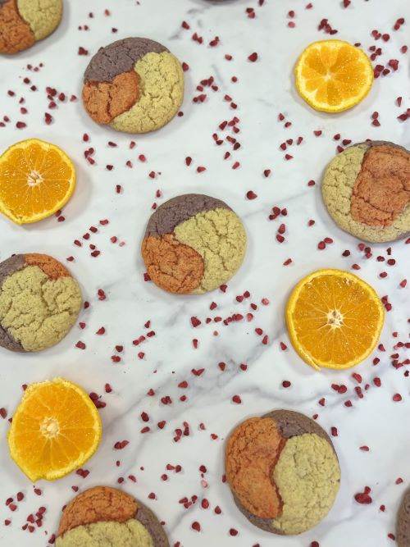
Ingredients:

Macphie Soft and Chewy Cookie Mix 1.000Kg

Water 0.120Kg

Braun Dessert Paste Raspberry 1 ½ tsp

Braun Dessert Paste Lemon 3 tsp

Orange Blossom Water 1 ½ tsp

Orange Food Colouring ¼ tsp

Method:

Add the cookie mix and the water together in a bowl and mix until combined

Separate the dough equally into 3 separate bowls

In one bowl add the lemon dessert paste and mix

In another bowl add the orange blossom water and orange food colouring and mix

In the last bowl add the raspberry dessert paste and mix

Roll out each of the 3 doughs into 20g balls

Get a lemon dough ball, orange dough ball and raspberry dough ball and roll them together to create a larger 60g dough ball

Place in the fridge to chill for 30 mins to 1 hour

In a preheated 180°C oven bake the cookies for 14 minutes

