Rhubarb and Custard Viennese Whirls

Ingredients:

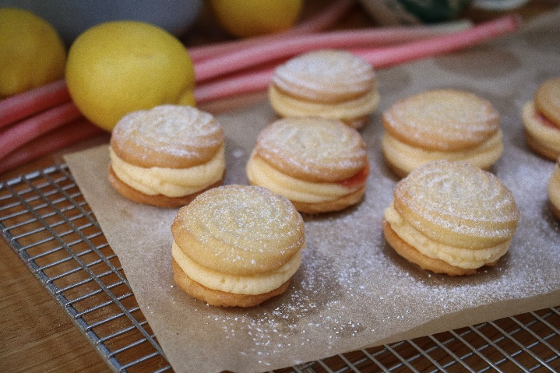
Matthews Organic Plain Flour 0.250kg

Ballyrashane Butter 0.250kg

Icing Sugar 0.075kg

Vanilla Flavouring 0.005kg

Baking Powder 0.002kg

Cornflour 0.015kg

Rhubarb Filling 0.200kg

Macphie Buttercream 0.450kg

Custard Powder 0.010kg

Milk 0.010kg

Method:

Start by creaming the butter and icing sugar until really light in colour. Add the flour, cornflour, vanilla, and baking powder along with a pinch of salt. Mix again until it’s super soft and fluffy it should almost be the consistency of a buttercream icing.

Put the biscuit mix into a piping bag fitted with a star nozzle and pipe small rosettes onto a lined baking sheet. I like to aim for about 2 inches across.

Put the baking tray into the fridge to chill for at least 30 minutes before baking. Preheat the oven to 180 degrees Celsius once the biscuits are ready, bake them for 12-15 minutes or until just starting to brown on the edges. They will firm up more as they cool.

Transfer the biscuits to a wire cooling rack

Add in the Macphie buttercream, custard powder and the milk, into a bowl and mix together

To assemble the Viennese whirls, take one of the biscuits and invert it. Pipe buttercream onto the flat side of the biscuit as well as a border to stop any jam leaking out. Place about a teaspoon of the Rhubarb filling onto the buttercream and sandwich it all with another biscuit. Repeat until all your biscuits are gone!

