Seasonal Doughnuts
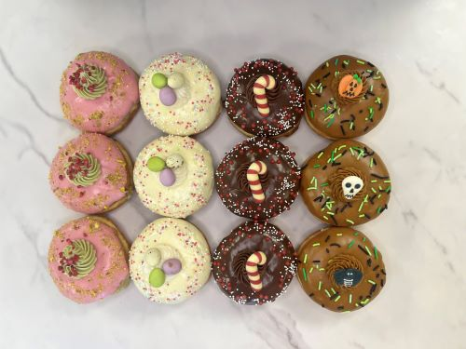

Ingredients:

Macphie Premium Doughnut Donut Concentrate 1.000Kg

Carr’s Bakers Flour 1.000Kg

AB Mauri Pinnacle Baker’s Yeast 0.08Kg

Water 0.84Kg
Seasonal | Filling | Topping | Frosting
Halloween | Biscoff | Macphie 5th Avenue Caramel | Macphie Speculoos Frosting
Christmas | IRCA Nocciolata and Braun Orange Dessert Paste | Coverdecor Dark Chocolate | Macphie Chocolate Frosting
Easter | IRCA Nocciolata Bianca | Coverdecor White | Macphie Vanilla Frosting
Summer | Crema Vela Pistachio | Coverdecor Strawberry | Crema Vela Pistachio and Macphie Vanilla Frosting

Our Flavour Choices

Method:

Use water tempered to give a final dough temperature of 28ºC (82ºF).

Mixing Time: •

Conventional Mixer: 10-15 minutes on middle speed. •

Spiral Mixer: 2 minutes on slow and 8 minutes on fast speed. •

High Speed mixer: 2-3 minutes (11 watt hours per kg of dough).

Scale dough pieces at 50g each (approx.)

Proof at 38ºC (100ºF) 75-80% R.H. for approx. 30-40 minutes.

Fry at ¾ proof. Remove doughnuts from prover 5-10 minutes before frying to allow a dry skin to form.

For a 50g (1¾oz) unit fry 190-195ºC (375-385ºF) for 90 seconds per side

